-------Install keycloak-------
1 ) Check java version
java -version
output :
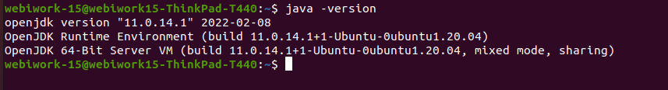

2) if it not install install java
- sudo apt update
- sudo apt install default-jdk
- java -version
output:
3) “opt” my command

*- cd /opt
4) download keycloack:
sudo wget https://github.com/keycloak/keycloak/releases/download/16.1.1/keycloak-16.1.1.tar.gz
5) extract keycloack
sudo tar -xvzf keycloak-16.1.1.tar.gz
6) move keycloack to opt
sudo mv keycloak-16.1.1 /opt/keycloak
7) add group to keycloack
sudo groupadd keycloak
8) add user to keycloack
sudo useradd -r -g keycloak -d /opt/keycloak -s /sbin/nologin keycloak
9)modify ownership and permission of /opt/keycloak directory. //*** don’t go to keycloak dir just run below command from “opt”
- sudo chown -R keycloak: keycloak
- sudo chmod o+x /opt/keycloak/bin/
10) go to etc directory
- cd /etc/
11) make keyclock direcrory
- sudo mkdir keycloak
12) sudo cp /opt/keycloak/docs/contrib/scripts/systemd/wildfly.conf /etc/keycloak/keycloak.conf
13) sudo cp /opt/keycloak/docs/contrib/scripts/systemd/launch.sh /opt/keycloak/bin/
14) sudo chown keycloak: /opt/keycloak/bin/launch.sh
14.1) sudo nano /opt/keycloak/bin/launch.sh
- paste the code in terminal and save (ctrl +s) and close (ctrl +x)
#!/bin/bash

if [ "x$WILDFLY_HOME" = "x" ]; then
WILDFLY_HOME="/opt/keycloak"
fi

if [[ "$1" == "domain" ]]; then
$WILDFLY_HOME/bin/domain.sh -c $2 -b $3
else
$WILDFLY_HOME/bin/standalone.sh -c $2 -b $3
fi
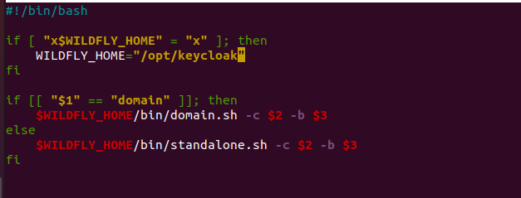
15) sudo cp /opt/keycloak/docs/contrib/scripts/systemd/wildfly.service /etc/systemd/system/keycloak.service
16) Open keycloak.service in an editor
- sudo nano /etc/systemd/system/keycloak.service
copy the paste the below code -----
[Unit]
Description=The Keycloak Server
After=syslog.target network.target
Before=httpd.service
[Service]
Environment=LAUNCH_JBOSS_IN_BACKGROUND=1
EnvironmentFile=/etc/keycloak/keycloak.conf
User=keycloak
Group=keycloak
LimitNOFILE=102642
PIDFile=/var/run/keycloak/keycloak.pid
ExecStart=/opt/keycloak/bin/launch.sh $WILDFLY_MODE $WILDFLY_CONFIG $WILDFLY_BIND
StandardOutput=null
[Install]
WantedBy=multi-user.target

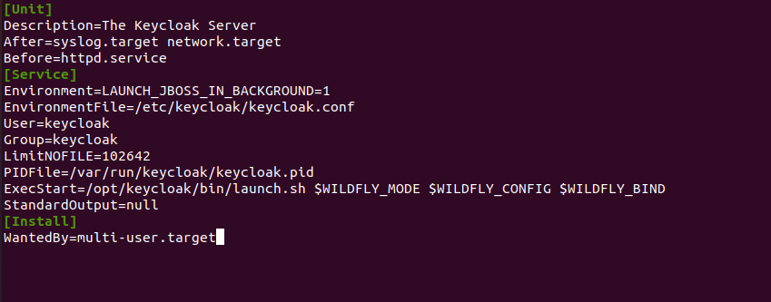
- for save (ctrl +s) and for close (ctrl +x)
17) Reload systemd manager configuration and enable keycloak service on system startup
- sudo systemctl daemon-reload
- sudo systemctl enable keycloak
18) to start keycloak system service:
- sudo systemctl start keycloak
for status ----
- sudo systemctl status keycloak

follow this link-
https://medium.com/@hasnat.saeed/setup-keycloak-server-on-ubuntu-18-04-ed8c7c79a2d9

19) Run url in browser (http://localhost:8080/)

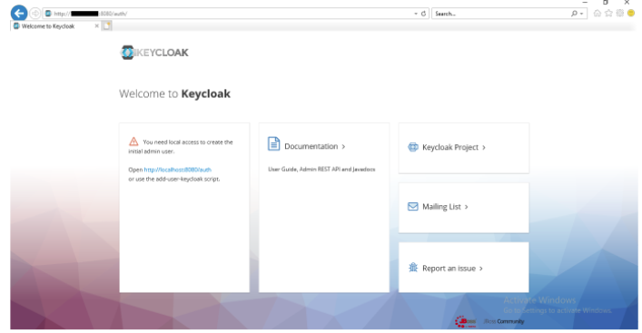
20).Create admin user- and go to admin console

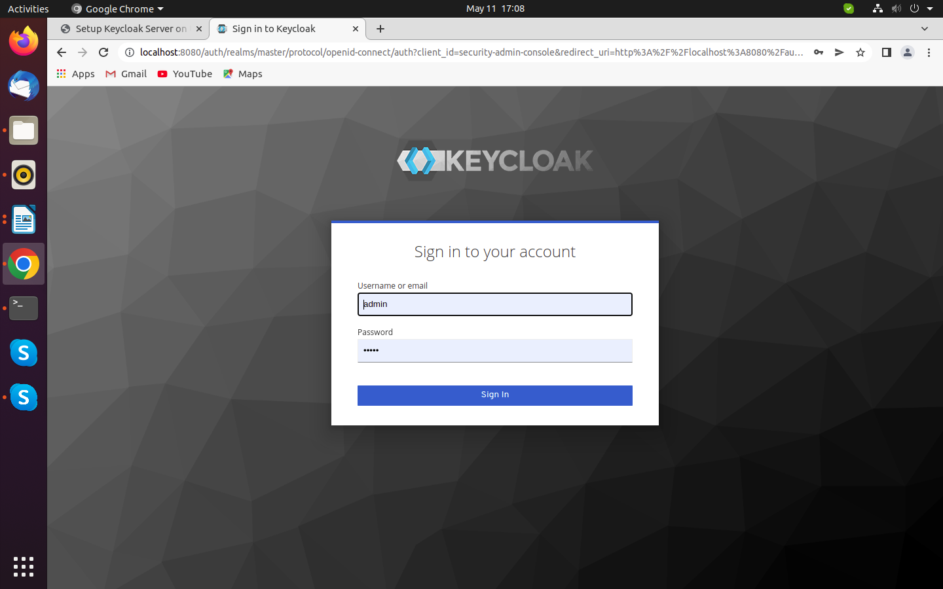
21) Admin login

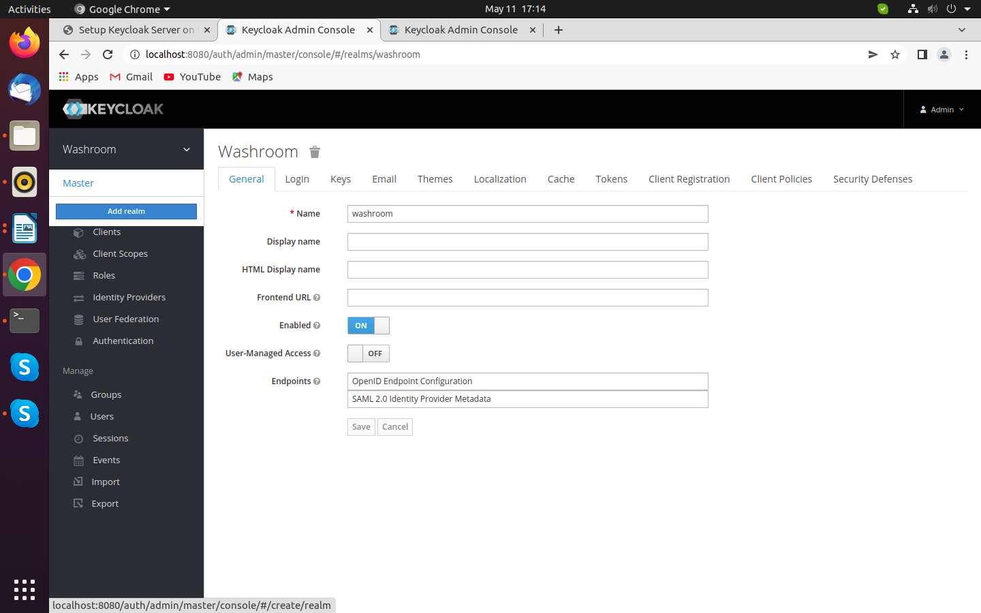
22)Add realm name washroom(“all in small letter”)
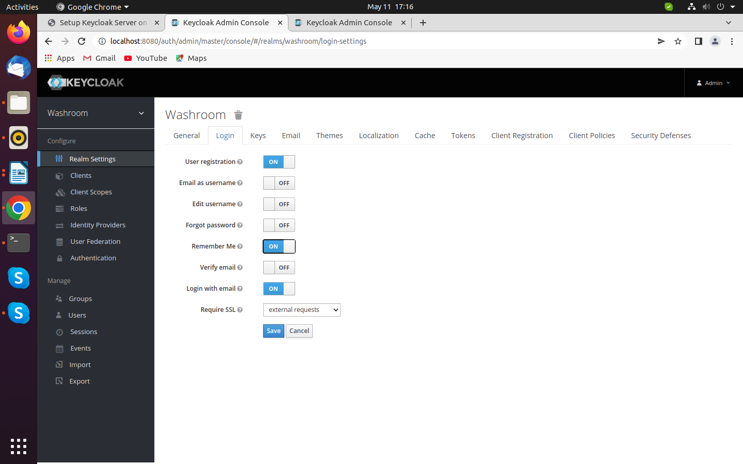
23) Enable user registration “on” and save it
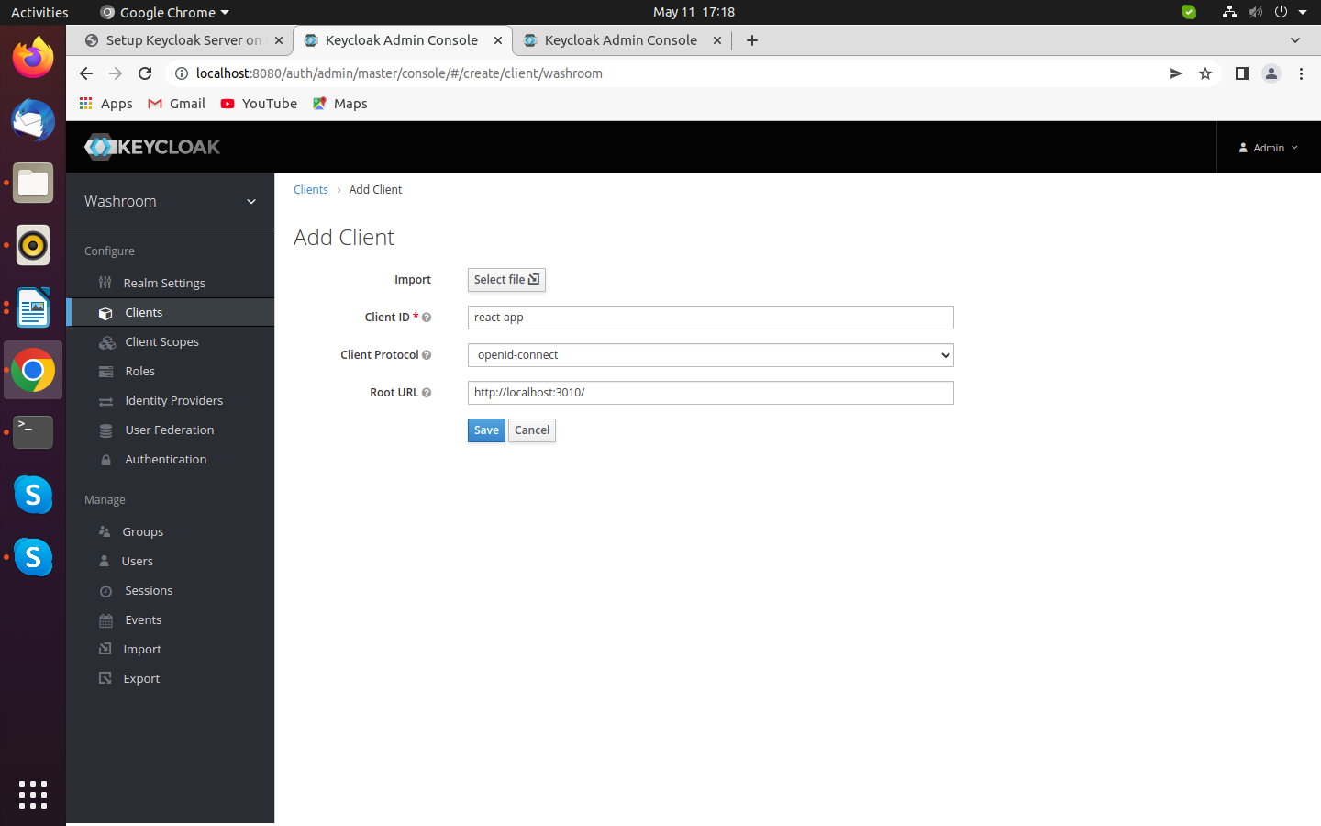
24)Add Client on client “Tab” name “react-app” and root url “http://localhost:3010” and save it
25) Add one more client name “nodejs-microservice” and root url “http://localhost:8081”
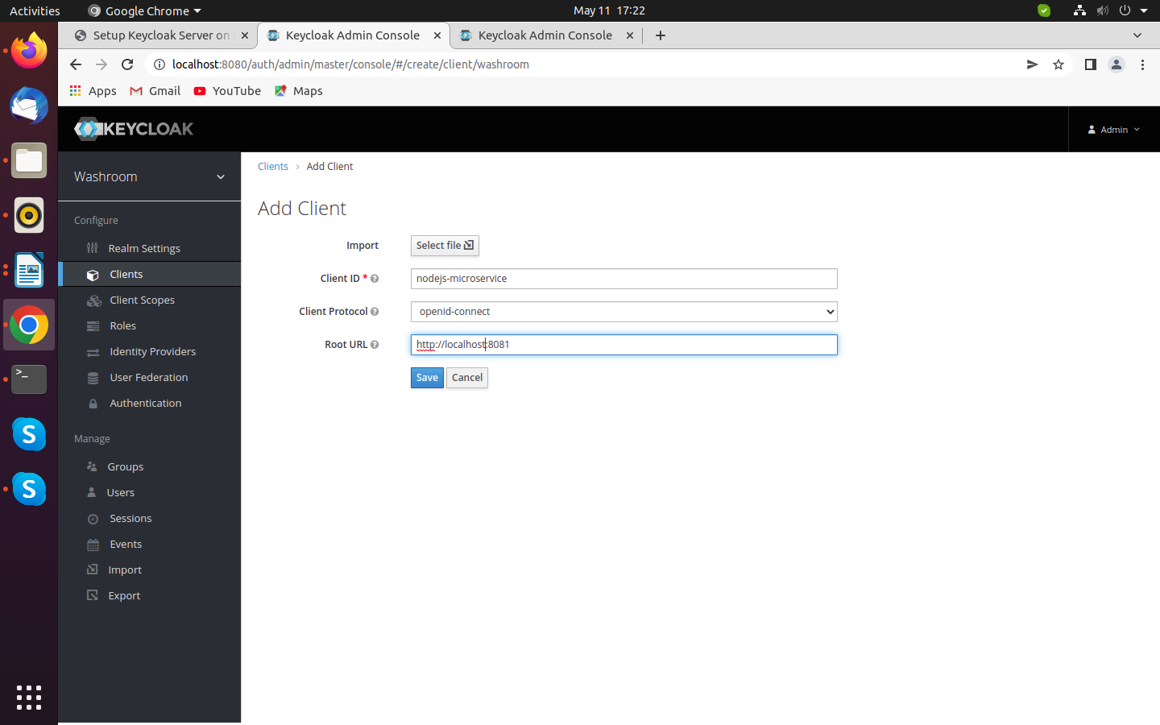
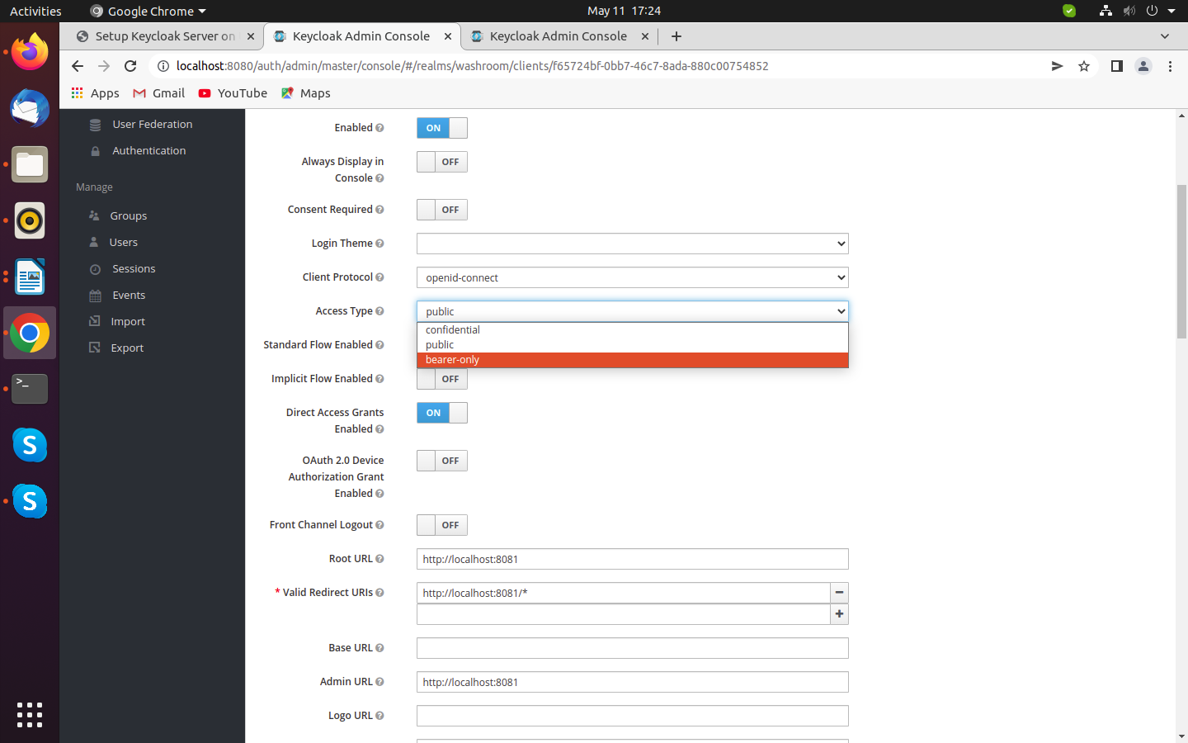
26) open “nodejs-microservice” client and change “Access Type” breaer-only save it

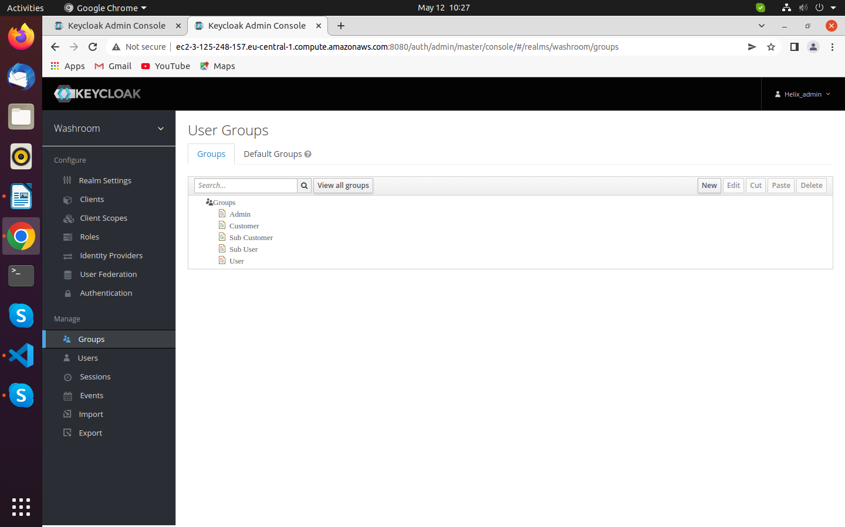
27) Add Admin new groups-

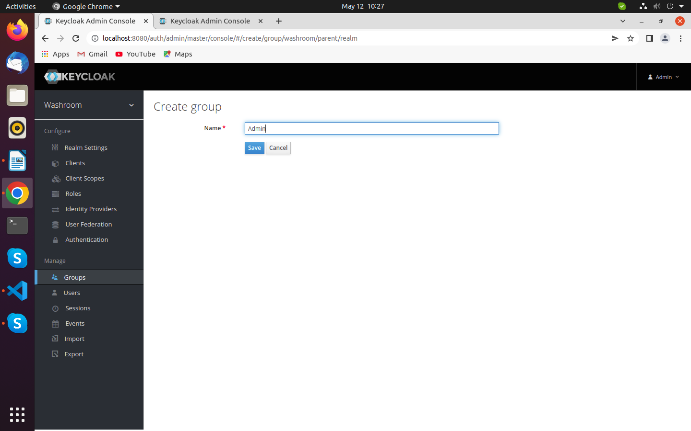
28). Create new group-

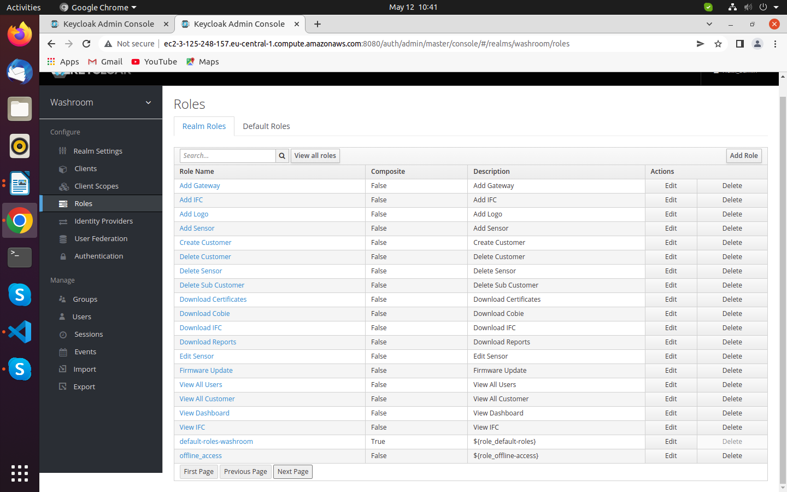
29) Go to Roles – Create and Add new roles ->
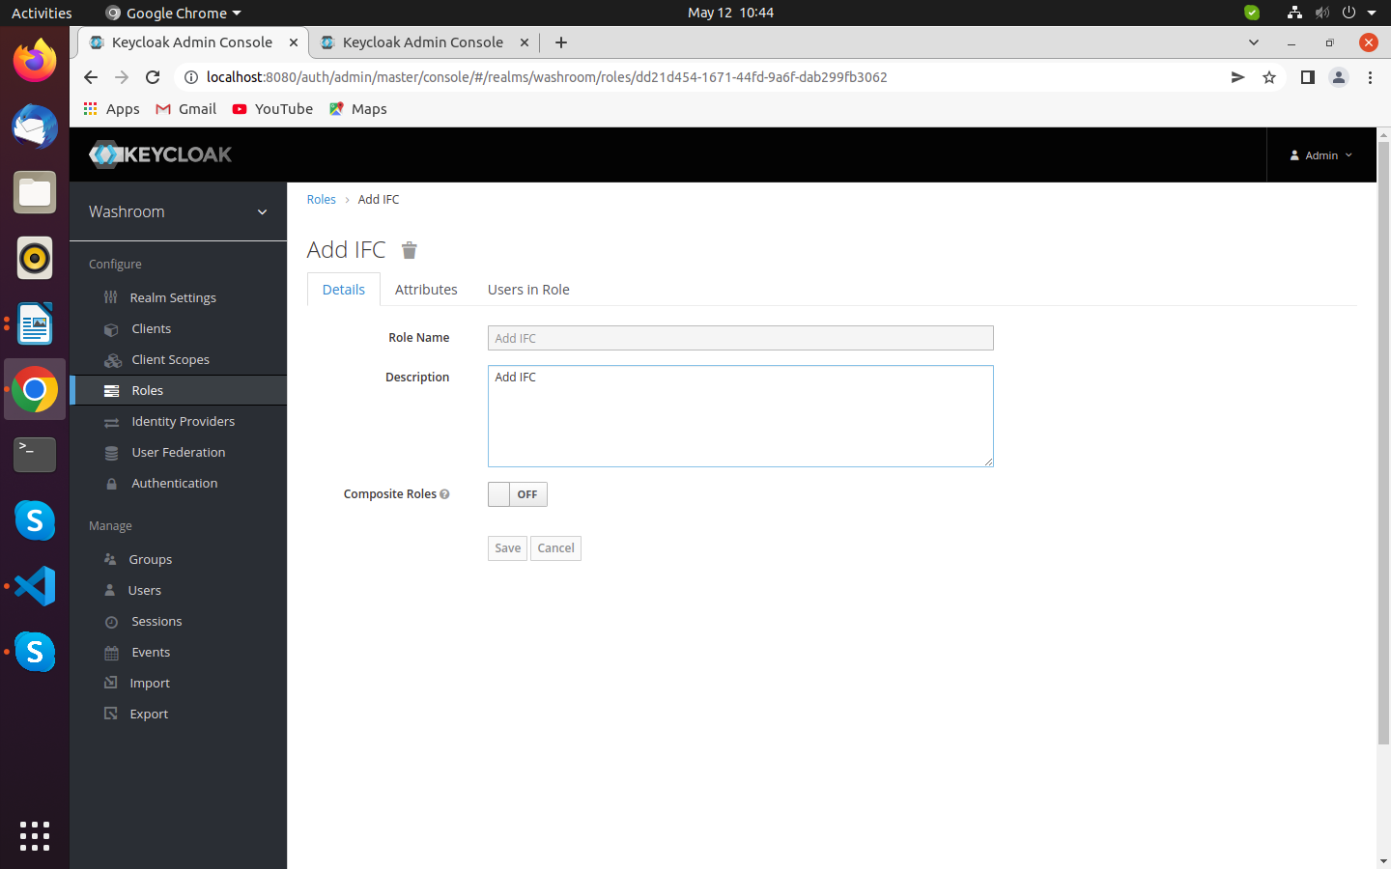
30) Add New Roles- and Save Roles ->

